**JavaBean Components**

JavaBeans are [classes](https://www.geeksforgeeks.org/classes-objects-java/)that [encapsulate](https://www.geeksforgeeks.org/encapsulation-in-java/) many objects into a single object (the bean).

It is a java class that should follow following conventions:

1. Must implement [Serializable](https://www.geeksforgeeks.org/serialization-in-java/).
2. It should have a public no-arg constructor.
3. All properties in java bean must be private with public getters and setter methods

#### Using a JavaBean in JSP page

* JavaBeans can be used in any JSP page using the <jsp:useBean> tag, For example:

<jsp:useBean id= "instanceName" scope= "page | request | session | application"

**class**= "packageName.className" type= "packageName.className"

beanName="packageName.className | <%= expression >" >

</jsp:useBean>

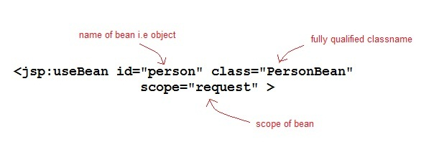

#### Using any JavaBean property in JSP page

* JavaBeans can be used in any JSP page using the <jsp:useBean> tag, <jsp:setProperty> tag and <jsp:getProperty> tag , For example:

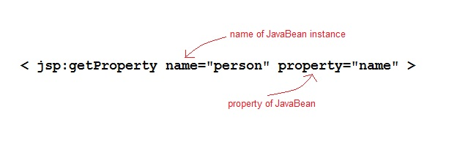

<**jsp:useBean** id="id" class="bean class name" scope="fully qualified path of bean">

<**jsp:setProperty** name="beans id" property="property name" value="value"/>

<**jsp:getProperty** name="beans id" property="property name"/>

...........

</**jsp:useBean**>